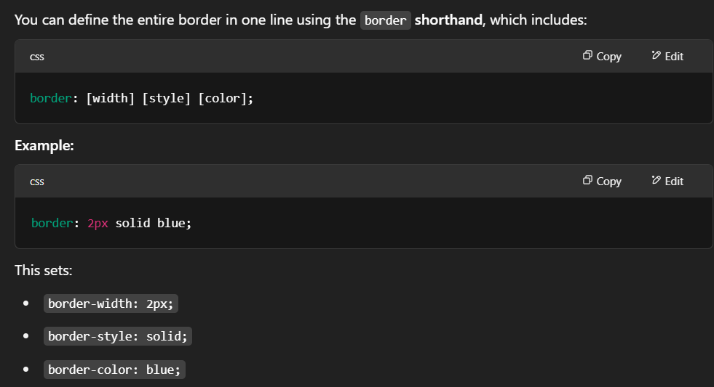

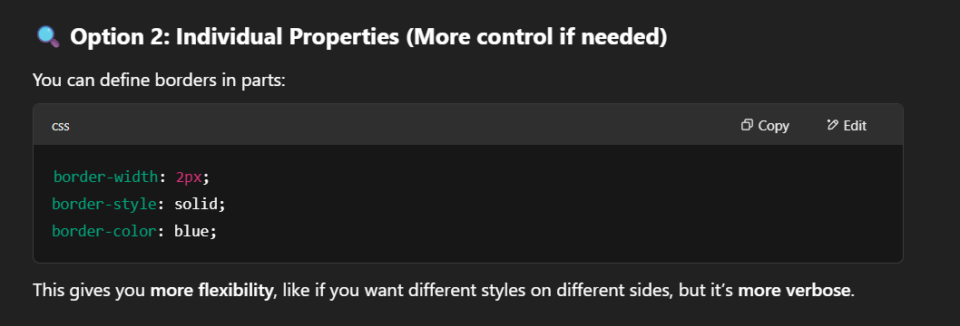

**Right Step :**

**border: 1px solid rgb(7, 7, 235);**

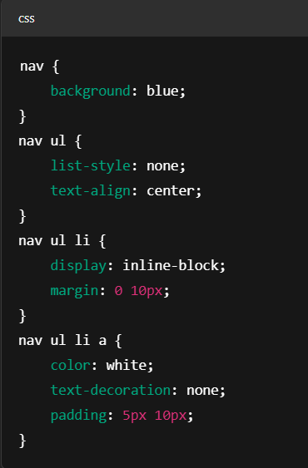

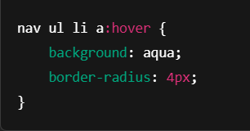



Which is called selector specificity , basically more specific than general element selector ..



Html entity :

Are used for symbol like check mark, logo appeared on webpage

Text element is needed to apply property inside paragraph or text..

.text2{

            cursor:pointer;

            color:red ;

        }

        .text2:hover{

            text-decoration: underline;

        }

